SAFARI TOUR EXPERIENCES FOR ALL
Explore Nairobi Where City Life Meets Wild Adventure.
Start your memorable adventure today.
Whether you're a wildlife lover, culture enthusiast, or history buff, Nairobi offers an unforgettable blend of natural beauty and rich heritage all in one vibrant city. Nairobi has it all wildlife, culture, history, and charm.

1. Nairobi National Park – Safari in the City. Visiting hours 6AM-10AM.Experience the wild just 7 km from downtown Nairobi! Nairobi National Park offers an unforgettable safari with lions, rhinos, giraffes, and over 400 bird species all set against the stunning city skyline. It’s the only place in the world where you can see big game with skyscrapers in the background.
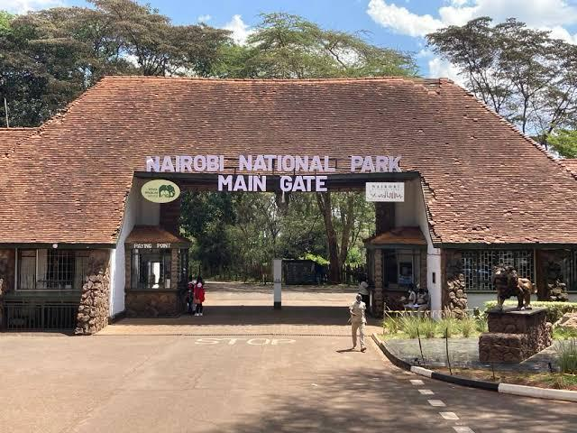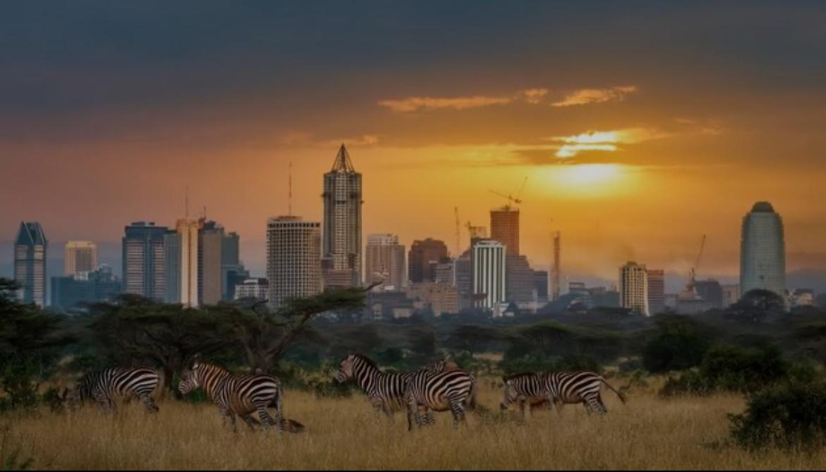
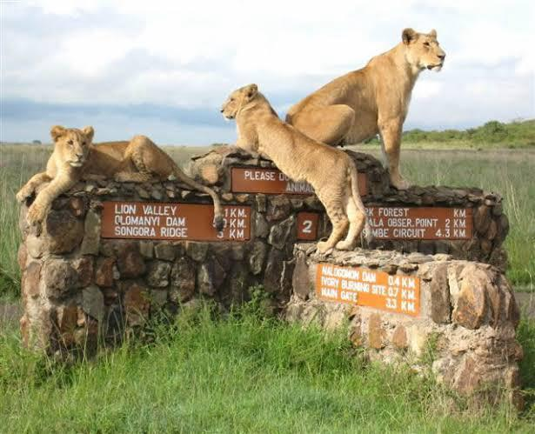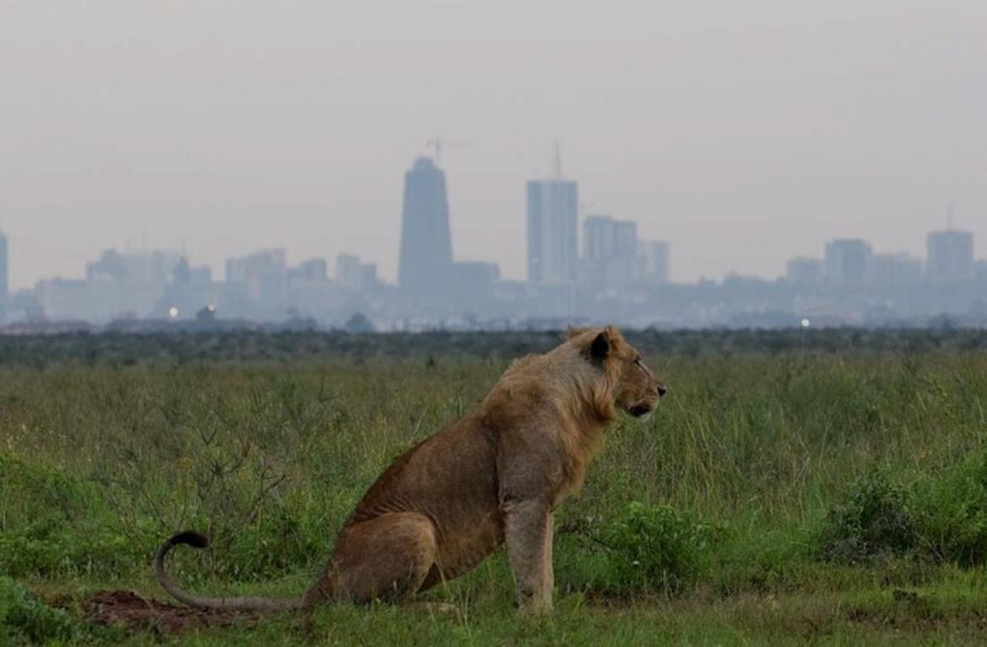
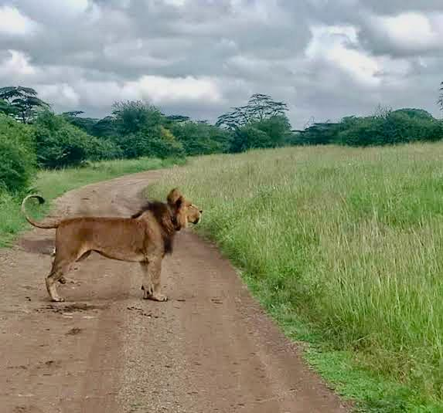
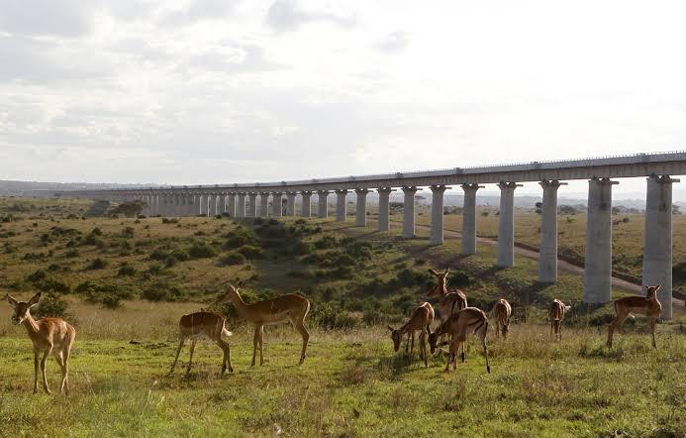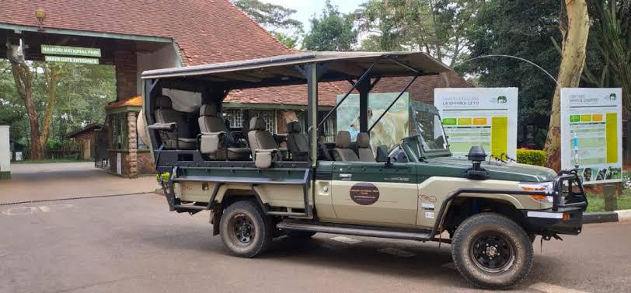

2. David Sheldrick Elephant Orphanage – Up Close with Baby Elephants.
Visiting hours (Strictly) 11 AM–12 PM. Meet rescued baby elephants at this heartwarming sanctuary inside Nairobi National Park. Watch them enjoy their daily mud baths and learn about their incredible journey from orphaned to rehabilitated.
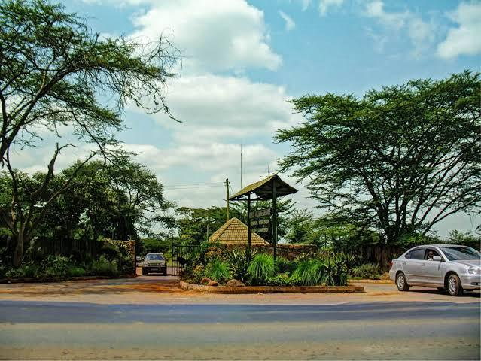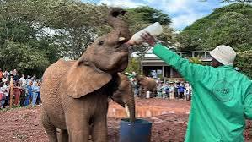
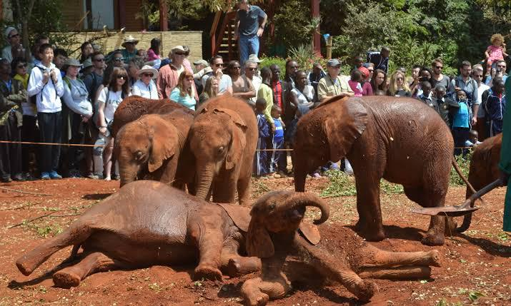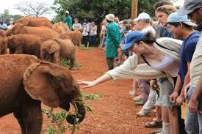
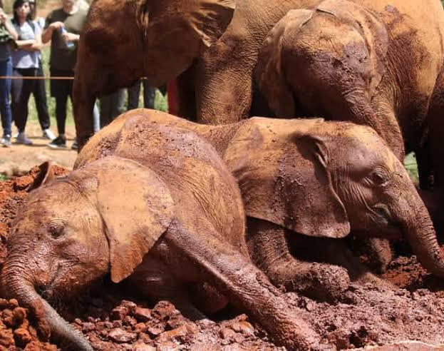

3. Giraffe Centre – Feed and Greet Friendly Giants. Visiting hours 2PM-3PMGet face to face with endangered Rothschild giraffes in Lang’ata. Hand feed them from a platform, enjoy a nature walk, and even score a giraffe kiss. A perfect mix of fun and education for all ages.
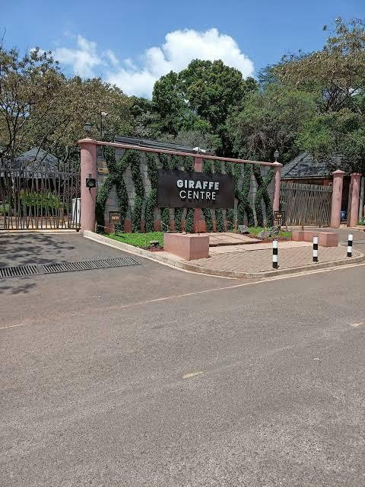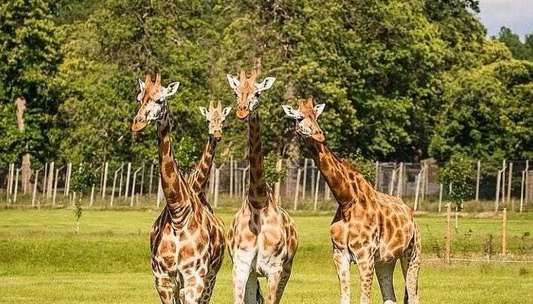
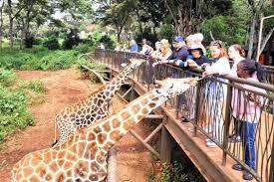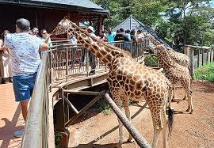
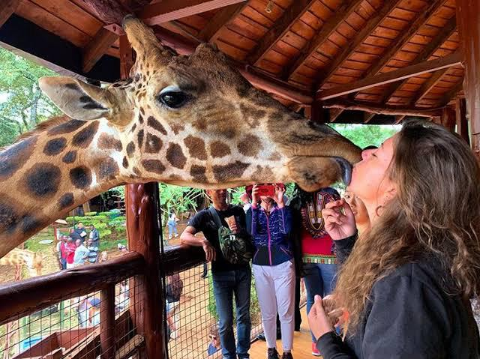

4. Nairobi National Museum – Explore Kenya’s Story. Visiting hours 3PM-5PM.Step into Kenya’s past with fascinating exhibits on fossils, wildlife, art, and culture. Don’t miss the neighboring Snake Park for a close look at reptiles. Ideal for curious minds and history lovers.
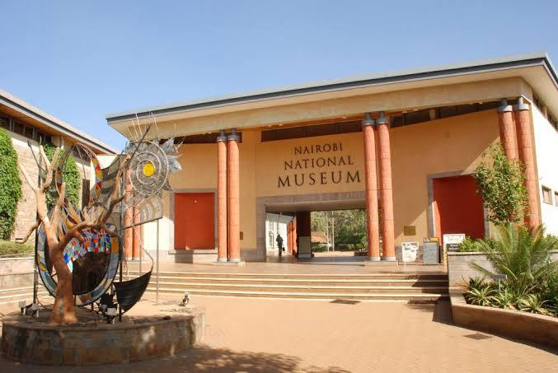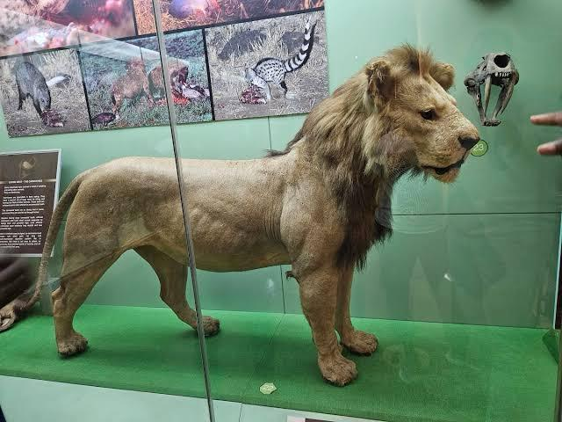
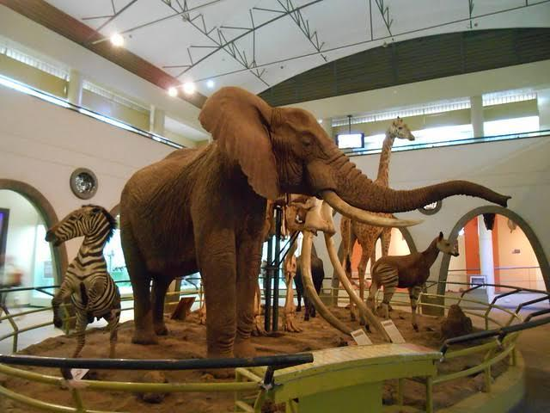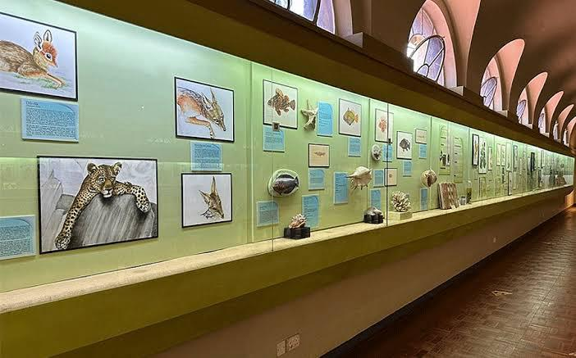
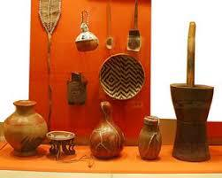

5. Bomas of Kenya – Dance Through Culture. Visiting hours 2:30PM-4PM.Celebrate Kenya’s vibrant heritage with thrilling traditional dance shows, music, and crafts. Tour life sized tribal homesteads and discover the lifestyles of Kenya’s diverse ethnic communities all just minutes from the city center.
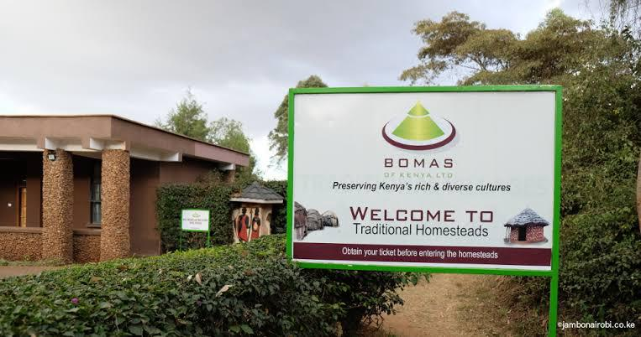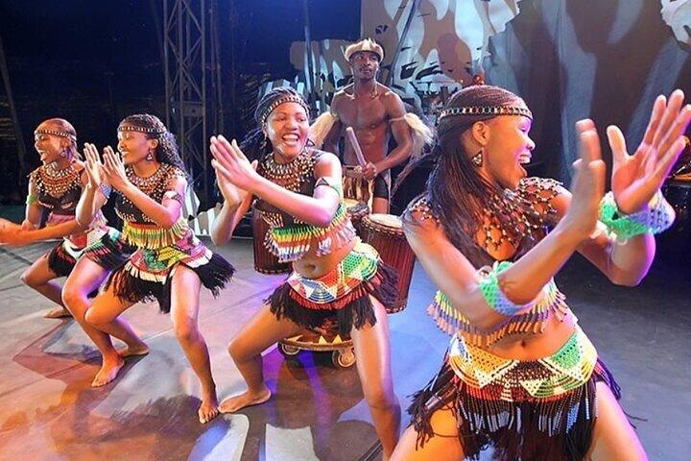
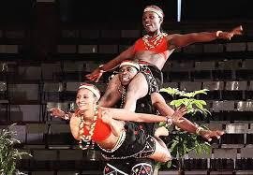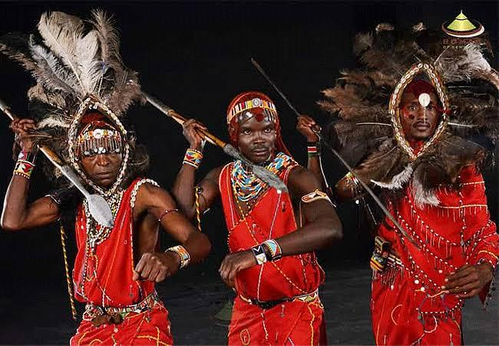
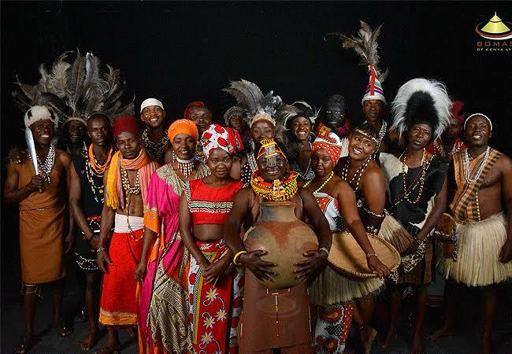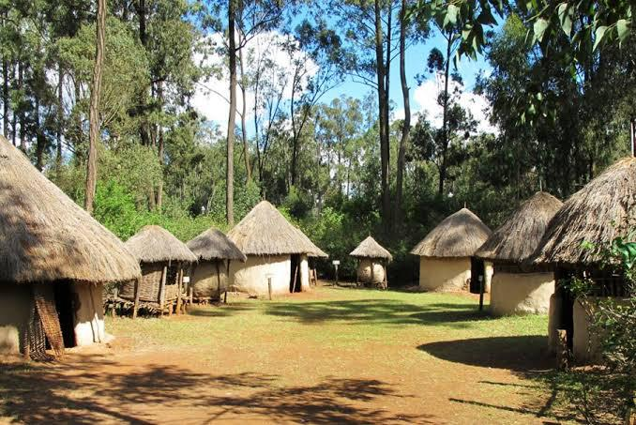

6. Karen Blixen Museum – A Taste of Colonial Charm. Visiting hours 10AM-4PM.Visit the beautifully preserved former home of the “Out of Africa” author. Located in the serene suburb of Karen, this museum offers a glimpse into colonial life and the history of coffee farming in early 20th century Kenya.
